Chapter 2: Mixtures

2.1 Mixtures are a combination of two or more substances

Literacy support worksheet answers (pages 30–31)

Mixtures

Part 1 – In the mix

What goes into a simple cup of tea?

1 This is a list of substances that make up a typical cup of tea: tea bag, milk, water, sugar, and a cup. Write ‘pure’ or ‘mixture’ next to each substance in the diagram below.

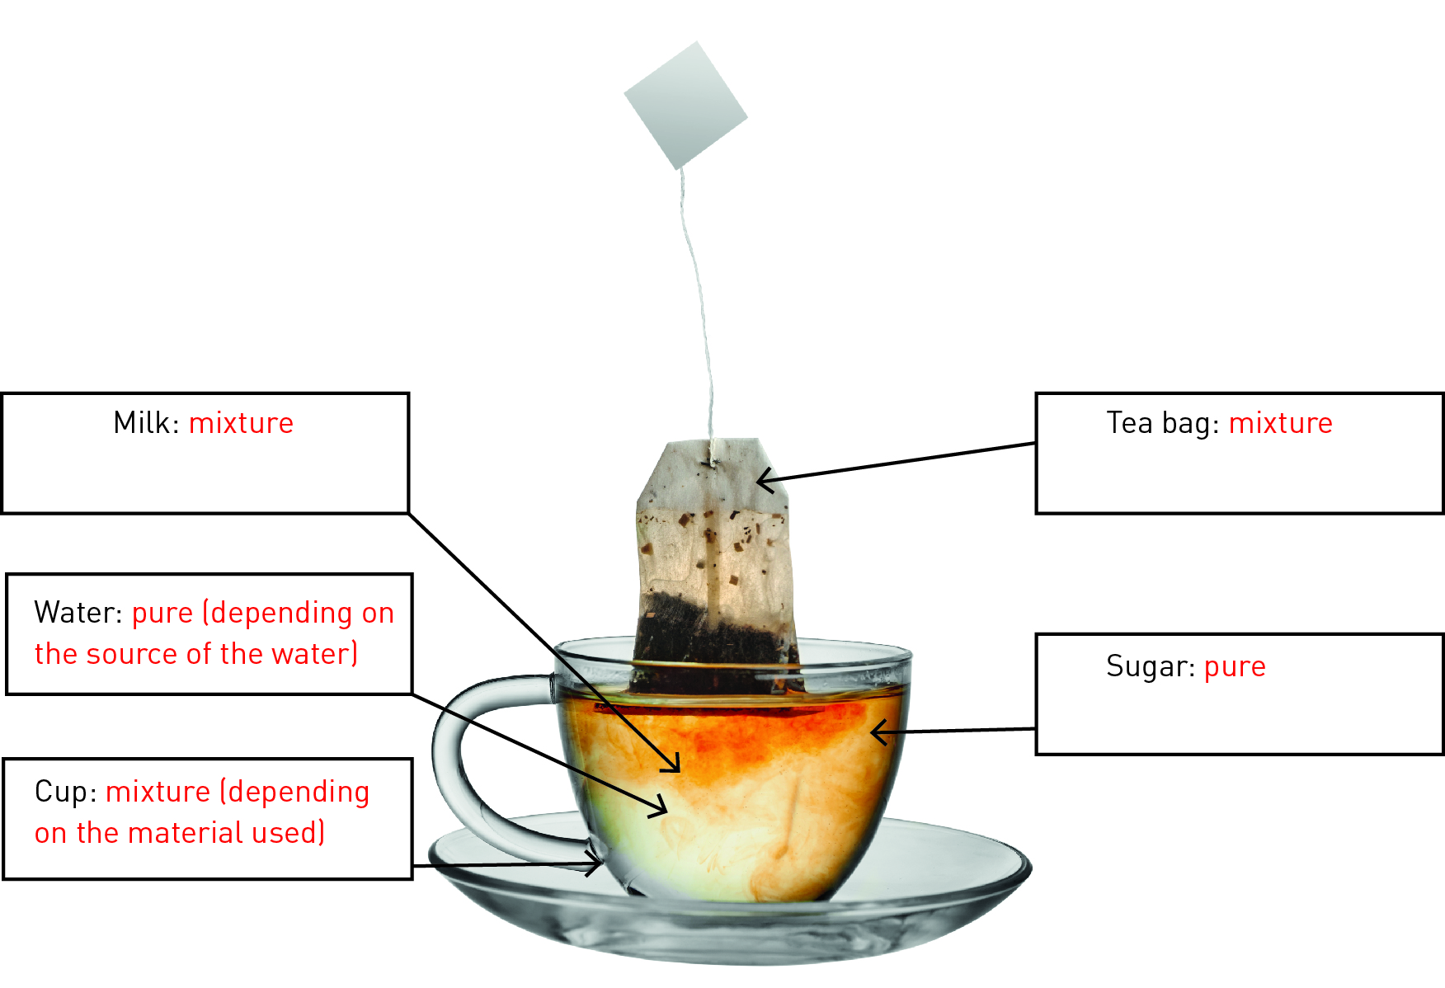

WORD DETECTIVE

2 Secret message

Use words from the student book to work out the secret message below:

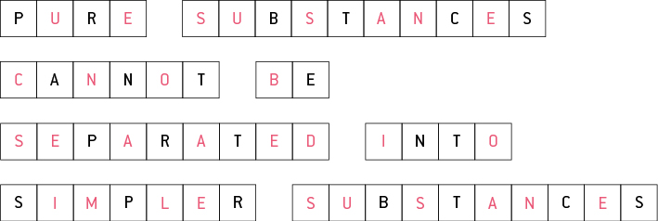

Part 2 – The suspense is building

3 The diagram below shows how small rocks and sand are carried by waves onto the beach.

a Think about a beach you have visited. What types of materials are washed up onto the beach?

Student responses will vary, but most should mention sand, seaweed, sticks, rubbish and shells as materials deposited on a beach.

b What substances would be in *suspension* in seawater?

The main substance in suspension in seawater would be sand, although other substances, such as microscopic living organisms, human pollutants etc., would also be in suspension.

WORD DETECTIVE

4 Word search

Find the words listed, in the puzzle below.

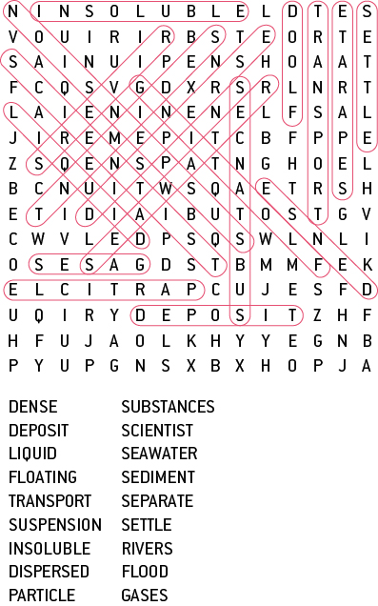

Part 3 – What are colloids?

A colloid is a suspension that does not separate easily.

5 Some drinks, for example chocolate-flavoured milk, are a mixture of a colloid and a suspension.

When you have chocolate-flavoured milk, you need to shake it before you open the container to drink it.

a Do you need to do the same to a container of plain milk before opening it?

Plain milk is a colloid, so does not need shaking before opening.

b After you shake chocolate flavoured milk, it is a suspension. The milk doesn’t separate easily so it is also a colloid. In chocolate milk there are two liquids, so it can be called an emulsion.

6 Draw and label four different examples of colloids below.

Student answers will vary

WORD DETECTIVE

7 Match-a-word

Draw a line from the words to their meanings.

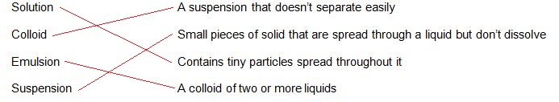

2.2 A solution is a solute dissolved in a solvent

Literacy support worksheet answers (pages 32–33)

Is there a solution?

1 Use the word list below to name the main solute and solvent in the food or drink in the table.

|  |  |  |
| --- | --- | --- |
| Substance | Solute  (the substance that dissolves into a liquid) | Solvent  (the liquid the substance dissolves into) |
| Hot chocolate | Chocolate | Water |
| Black coffee | Coffee granules | Water |
| Instant gravy | Gravy granules | Water |
| Jelly | Jelly crystals | Water |
| Soda (carbonated) water | Carbon dioxide gas | Water |

2 Solutions are generally see-through or transparent. Which of the foods or drinks above are solutions?

Jelly and soda water could both be considered solutions because the solute dissolves completely in the solvent.

3 Look at the bottle and the jug below. Both have been filled with a blue solution, (like cordial) but one is more concentrated than the other.

a Draw a diagram showing the solute particles in each one.

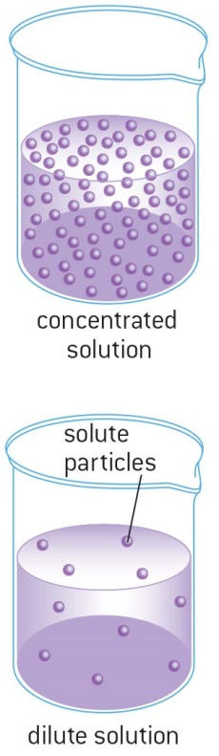

b Which container has the lowest (or weakest) concentration?

The jug has the lowest concentration of the solute.

d How could you make both of the solutions more dilute (weaker)?

Adding more solvent (water) would dilute both solutions.

WORD DETECTIVE

4 Crossword

Read the clues below and place the correct answers in the crossword boxes.

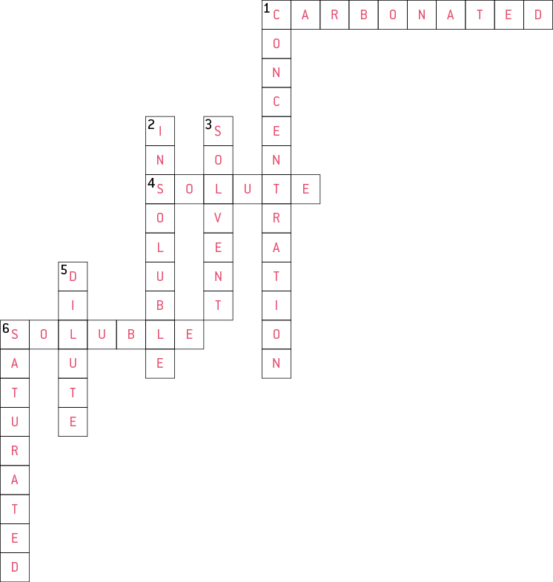

2.3 Mixtures can be separated according to their properties

Literacy support worksheet answers (pages 34–35)

Separate properties

1 What process would you use to separate each of the mixtures below?

a Simple separation should be used: fingers could easily separate the different types of lollies.

b Magnetic separation would be used to separate the different varieties of metal, particularly magnetic and non-magnetic.

c Decanting would allow the water to poured off in order to separate it from the solid sediment.

2 Your science teacher brings a large bucket to class with water, sand, iron nails and grass clippings. Draw and write how you would separate this mixture using a different method for each step. Think about which method you would use first.

Bucket containing water, sand, iron nails and grass clippings.

↓

The grass clippings would be floating on top, and so could be removed by scooping them up with a spoon.

The diagram should show a bucket with a spoon scooping out grass clippings.

↓

The iron nails could be separated next by magnetic separation, using a magnet dipped into the bucket.

The diagram should show a magnet being lowered into the bucket and nails attached to the magnet.

↓

The water can be separated by decanting the liquid into another container.

The diagram should show water being tipped out of the bucket.

↓

The sand should remain as a sediment in the bottom of the bucket.

The diagram should show a bucket with sand in the bottom.

WORD DETECTIVE

2 Secret message

Use words from the student book to work out the message below.

MAGENTS CAN BE USED TO SEPARATE OBJECTS

2.4 Mixtures can be separated according to their size and mass

Literacy support worksheet answers (pages 36–37)

Separating mixtures

1 Below are two different filters, a HEPA filter and a colander.

Describe at least two features both filters have in common.

Both these filters separate large particles from smaller particles. Both have a series of holes that let smaller particles pass through.

WORD DETECTIVE

2 Secret message

Use words from the student book to work out the message below.

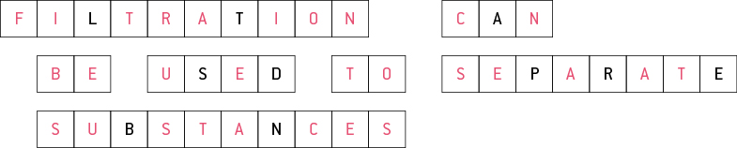

2.5 The boiling point of liquids can be used to separate mixtures

Literacy support worksheet answers (pages 38–39)

Going off the boil

1 Imagine you accidentally put sugar into a friend’s cup of tea. You decide to pour the cup of tea into a saucepan and boil it to separate the sugar from the tea.

a What method of separation are you using?

Crystallisation is the separation method used to separate the tea from the sugar.

b What crystals would remain in the saucepan?

Sugar crystals would remain in the saucepan.

2 Draw a labelled diagram to show how this process of separation would work.

Student answers will vary.

3 The table below shows the boiling points of common liquids. Use the data to create a column graph ranging from the lowest to the highest boiling point in the space provided.

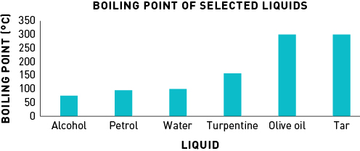

4 The diagram below shows the equipment used for distillation in the science laboratory. Label the equipment described in the table.

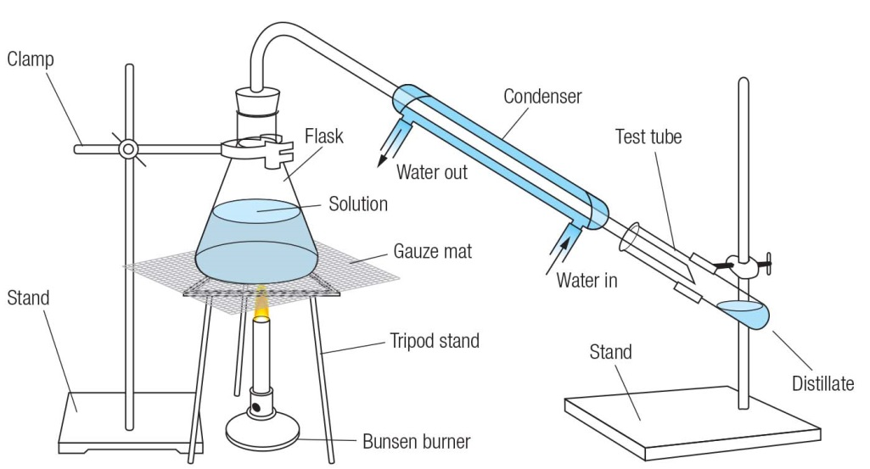

WORD DETECTIVE

5 Crossword

Read the clues below and place the correct answers in the crossword boxes:

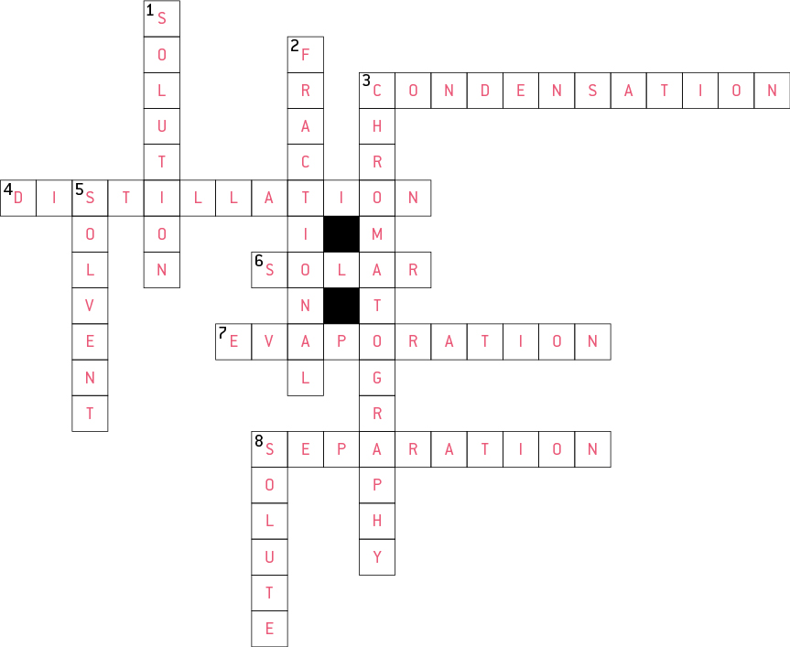

2.6 Solubility can be used to separate mixtures

Literacy support worksheet answers (pages 40–41)

A mixture to dye for.

1 In chromatography, the coloured dye that is most soluble is at the top of the paper, whereas the least soluble is at the bottom. The Rf value (retention factor) can be calculated as the distance travelled up the paper by a colour divided by the distance travelled up the paper by the solvent.

As an equation,

Calculate the Rf value for:

a purple

Purple travelled 2 cm, the solvent travelled 9 cm, so Rf  = 2 ÷ 9 = 0.22

b orange

Orange travelled 6 cm, the solvent travelled 9 cm, so Rf  = 6 ÷ 9 = 0.67

c blue

Blue travelled 8 cm, the solvent travelled 9 cm, so Rf  = 8 ÷ 9 = 0.89

WORD DETECTIVE

2 Match-a-word

Draw a line from the words to their meanings.

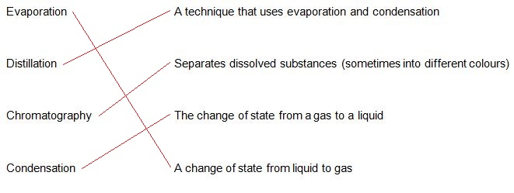

2.7 Science as a human endeavour: Waste water is a mixture that can be separated

Literacy support worksheet answers (pages 42–43)

What a waste

1 Use the information on pages 42–43 and the words below to fill in the gaps in the diagram.

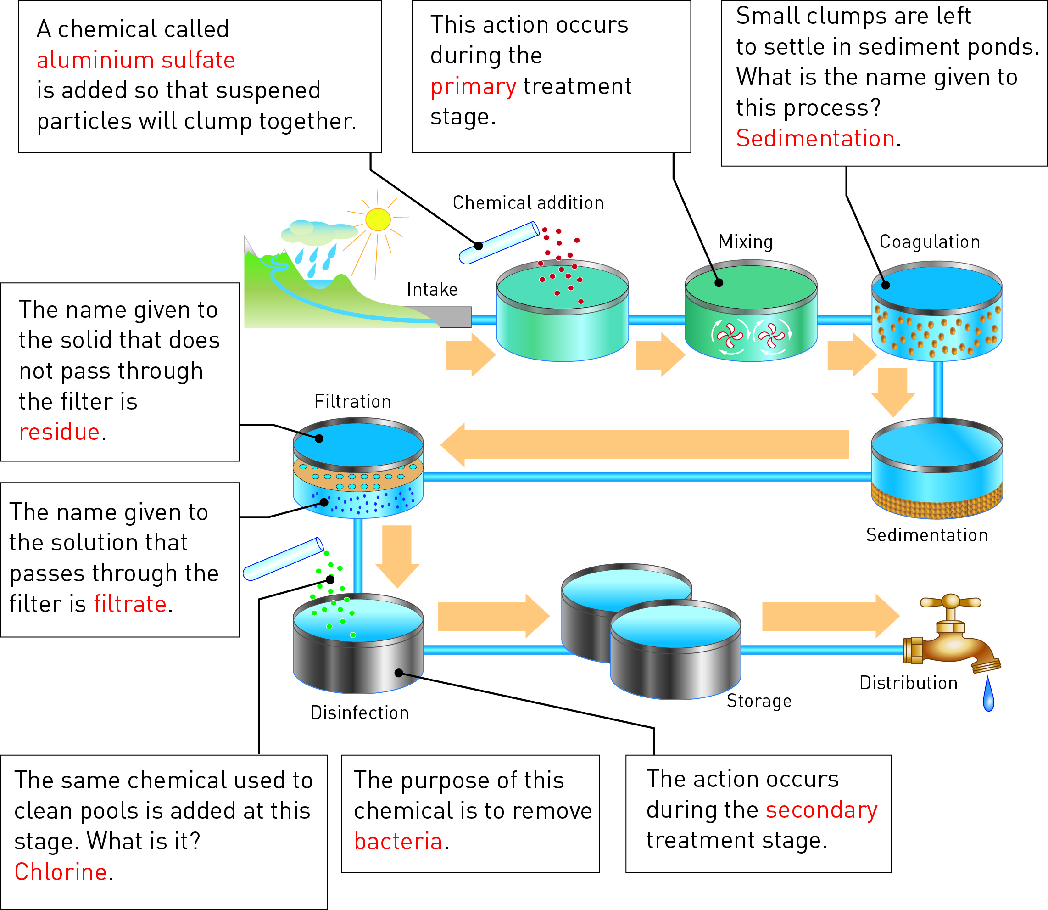

2 Secret message

Use words from the student book to work out the message below:

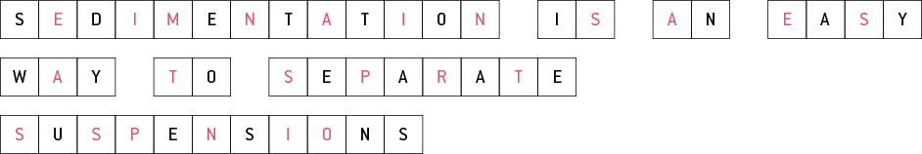

WORD DETECTIVE

3 Word search

Find the words listed, in the puzzle below.

